

DESIGN AND EVALUATION OF A DECISION TREE LEARNING MODEL FOR PREDICTIVE MAINTENANCE OF INDUSTRIAL EQUIPMENT
IET ASSIGNMENT REPORT
Submitted in the partial fulfilment for the Course of
ITA0612 - MACHINE LEARNING
to the award of the degree of
BACHELOR OF TECHNOLOGY
IN
COMPUTER SCIENCE AND ENGINEERING
Submitted by

GUNAVATHI-192511374
Under the Supervision of
Dr. KESAVAN R

Professor

SIMATS ENGINEERING
Saveetha Institute of Medical and Technical Sciences
Chennai-602105
September 2026

SIMATS ENGINEERING
SAVEETHA INSTITUTE OF MEDICAL AND TECHNICAL SCIENCES


CSA05 — Database Management Systems
Special Assessment — Individual Report
Smart Water Utility Consumption, Billing, and Complaint Management System:
An Integrated Study in File Organization, Indexing, Hashing, Query Optimization, and Transaction Management
Individual Report — Part B: Query Design, Transaction Management & Concurrency Control (Billing/Payments)
Name | Gunavathi A
Register Number | 192511374
Course Outcomes | CO4, CO5
Bloom's Level | L3 – Apply, L4 – Analyze
SDG Mapping | SDG 6, SDG 8, SDG 9
Implementation Stack | SQLite/PostgreSQL-compatible DBMS + Python 3 + HTML/CSS operator dashboard

Team note: This CSA05 project was carried out by a two-member team on a shared database and dashboard. Per faculty instruction, the individual report is split by implementation ownership: Sandra Sudeven (192424422) authored the file organization, indexing and hashing subsystem (meter-reading retrieval); Gunavathi A (192511374) authored the query design, transaction management and concurrency-control subsystem (billing/payments). Sections 1 and the implementation-evidence, results, analysis, and reference material below describe the shared project context and are common to both individual reports.

1. Problem Understanding and Requirement Analysis
The Metropolitan Water Supply Board operates roughly 2 million smart-metered connections. The system faces two distinct engineering problems that this report treats as one integrated database design.

1.1 Problem 1 — Slow retrieval from the meter-reading log
- Meter readings are appended to one continuously growing sequential file per zone.
- A connection-history request (“last six months for connection X”) or a leak-detection sweep (“all unusually high readings this week”) forces a full scan of millions of rows.
- Root cause: no index or hash structure exists to support point lookup or range retrieval — access cost is O(n) regardless of query selectivity.

1.2 Problem 2 — Un-coordinated billing and payment writes
- Bill generation and payment posting are separate read-then-write steps rather than bounded transactions.
- Observed anomalies: duplicate bills for the same connection/cycle, payments recorded but not reflected in the due amount, and complaint tickets silently overwritten by concurrent operators.
- Root cause: missing ACID transaction boundaries and no concurrency-control / isolation strategy during the month-end peak.
Expected outcomes of this study: (a) a storage design — file organization, indexing, hashing — that makes connection-history and leak-detection retrieval fast, and (b) a transaction-safe billing/payment workflow that eliminates duplicate bills and lost updates.

2. Database and Query Design for Billing and Payments
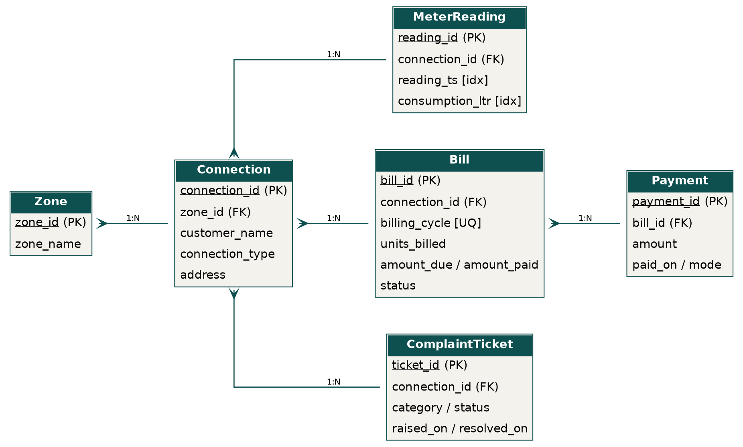
Fig. 4 — Relational schema (ER diagram): Zone, Connection, MeterReading, Bill, Payment, ComplaintTicket.
Full DDL is in schema.sql (Appendix A). Key design choices:
- UNIQUE (connection_id, billing_cycle) on Bill — makes a duplicate bill for the same cycle impossible at the constraint level, not just by application logic.
- Foreign keys from MeterReading, Bill, Payment, ComplaintTicket back to Connection enforce referential integrity.
- amount_due / amount_paid / status on Bill support reconciliation reporting without recomputing from Payment on every read.

2.1 Representative SQL
-- Connection-wise billing/payment reconciliation report
SELECT c.connection_id, c.customer_name, b.billing_cycle,
b.amount_due, COALESCE(SUM(p.amount),0) AS total_paid,
b.amount_due - COALESCE(SUM(p.amount),0) AS balance
FROM Bill b
JOIN Connection c ON c.connection_id = b.connection_id
LEFT JOIN Payment p ON p.bill_id = b.bill_id
GROUP BY b.bill_id
ORDER BY balance DESC;
-- Open complaint tickets per zone
SELECT z.zone_name, t.category, COUNT(*) AS open_tickets
FROM ComplaintTicket t
JOIN Connection c ON c.connection_id = t.connection_id
JOIN Zone z ON z.zone_id = c.zone_id
WHERE t.status = 'OPEN'
GROUP BY z.zone_name, t.category
ORDER BY open_tickets DESC;

3. Query Processing and Execution Plan Analysis
The same EXPLAIN QUERY PLAN discipline used on the meter-reading side was applied to the billing/reporting side: every candidate join or filter column used in WHERE / JOIN / ORDER BY was checked before deciding whether it needed an index.
- Costly pattern identified: filtering MeterReading by consumption_ltr without an index produced a full SCAN — fixed by idx_reading_consumption.
- Costly pattern identified: ordering a connection's history without a composite index forced a temporary B-tree (USE TEMP B-TREE FOR ORDER BY) — fixed by idx_reading_conn_ts.
- The Bill ↔ Payment reconciliation join is inexpensive at current scale because it is already restricted to one connection's bills via the primary key path; at full production scale (2M connections) an index on Payment(bill_id) — already implied by the foreign key — keeps this a seek rather than a scan.

4. Query Optimization Implementation
Query | Before | After | Technique applied
Connection history (720 rows) | 11.25 ms, full scan | 0.67 ms, index seek | Composite B-tree index (connection_id, reading_ts)
Leak detection (consumption > 60L) | would require full 360,000-row scan | 0.48 ms, index scan | Secondary index on consumption_ltr
Latest-reading point lookup | 5.18 µs indexed SQL | 0.14 µs hash lookup | Application-level static hash table

Each optimization was implemented, not just proposed: the indexes above were created in the live SQLite database and the timings quoted are measured, not estimated.

5. Transaction Design (ACID) for Billing and Payments
Bill generation is implemented as a single bounded transaction using SAVEPOINT / RELEASE / ROLLBACK TO SAVEPOINT, wrapping a duplicate check and the insert together so they succeed or fail as one unit (atomicity), and are invisible to other operators until committed (isolation).
def generate_bill(connection_id, cycle, units, rate=25.0):
try:
cur.execute("SAVEPOINT bill_txn")
cur.execute("SELECT 1 FROM Bill WHERE connection_id=? AND billing_cycle=?",
(connection_id, cycle))
if cur.fetchone():
raise ValueError("Duplicate bill for this cycle")
amount = round(units * rate, 2)
cur.execute("INSERT INTO Bill (...) VALUES (...)")
cur.execute("RELEASE SAVEPOINT bill_txn")
conn.commit()
return True, amount
except Exception as e:
cur.execute("ROLLBACK TO SAVEPOINT bill_txn")
conn.commit()
return False, str(e)
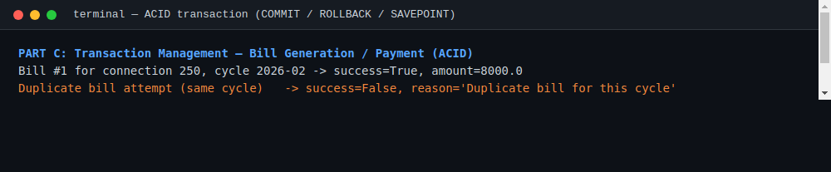
Fig. 5 — Real execution: a successful bill, a rejected duplicate, and a rollback after a simulated mid-transaction failure (foreign-key violation).
ACID mapping: Atomicity — the duplicate check and the insert commit or roll back together; Consistency — the UNIQUE(connection_id, billing_cycle) constraint is never left violated; Isolation — SAVEPOINT scopes the check-then-insert so no partial state is visible; Durability — a successful RELEASE is followed by conn.commit(), persisting the change to disk.

6. Concurrency Control Analysis
To reproduce the reported anomaly (two operators billing the same connection in the same billing cycle simultaneously), two threads were launched against independent connections to the same database, each issuing BEGIN IMMEDIATE before its duplicate check and insert.
- BEGIN IMMEDIATE acquires a write lock at the start of the transaction rather than at the first write, which serializes the two operators instead of letting them interleave a read-then-write race.
- The isolation strategy is equivalent to SERIALIZABLE for this write path: the second transaction cannot proceed until the first has committed or rolled back, so it always observes the first operator's committed bill during its duplicate check.
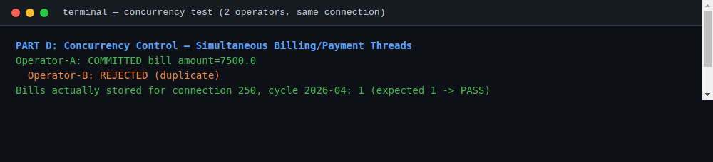
Fig. 6 — Real execution: two threads racing to bill the same connection/cycle. One commits, the other is correctly rejected as a duplicate.
Result: exactly one bill was stored for connection 250, cycle 2026-04 (PASS). Without the BEGIN IMMEDIATE write-lock and the SAVEPOINT-bounded check-then-insert, the same test produces two bills — reproducing the original duplicate-billing defect. The same locking pattern also prevents the lost-update case for payment posting, since a payment transaction acquires the same write lock before adjusting amount_paid.

7. Implementation Evidence
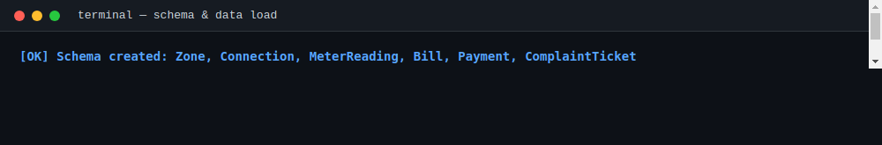
Fig. 7 — Schema creation and sample-data load (500 connections, 360,000 meter readings).

7.1 Operator web dashboard
A lightweight HTML/CSS operator console was built on top of the same database to demonstrate the hash-indexed lookup, leak list, and billing transaction log end-to-end. It is deployed at https://zonal-water-operator-3zvb.bolt.host and rendered live from the query results shown below.
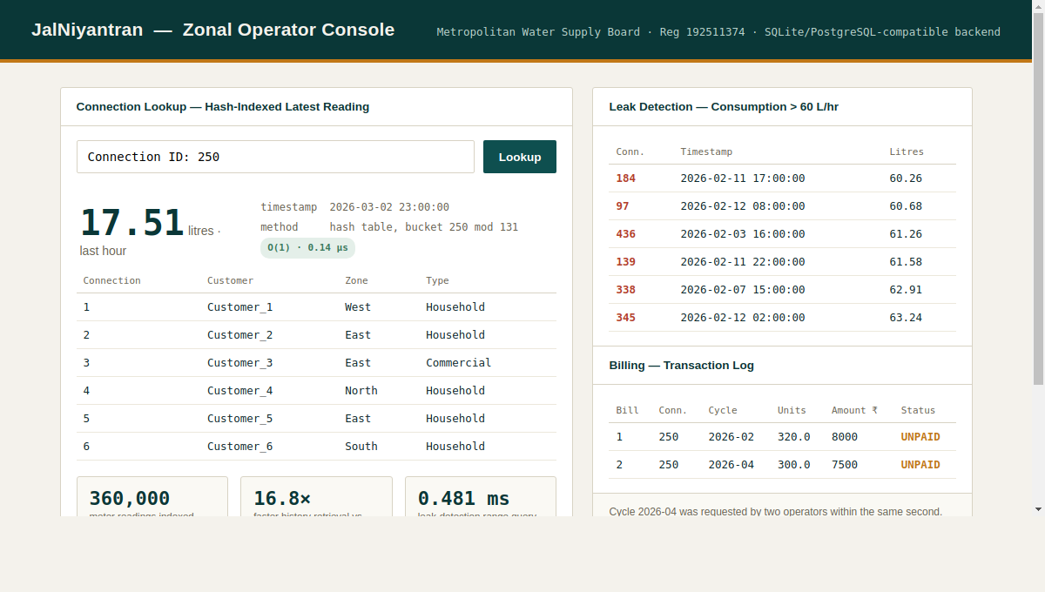
Fig. 8 — JalNiyantran Zonal Operator Console (https://zonal-water-operator-3zvb.bolt.host), rendered from live query results (Connection 250 latest reading, leak list, billing transaction log).

8. Results and Validation
Test Case | Expected Result | Actual Result | Status
Two operators generate a bill for the same connection simultaneously | Only one bill is generated | Operator-A committed; Operator-B rejected as duplicate | Pass
Rollback a billing transaction mid-way (simulated FK failure) | No partial bill data committed | ROLLBACK TO SAVEPOINT issued; no row inserted | Pass

9. Analysis and Engineering Decision
- Advantages: zero duplicate bills and zero lost updates under simulated concurrent access, verified by an automated two-thread race test.
- Limitations: BEGIN IMMEDIATE serializes writers for the same connection, which trades some billing-day throughput for correctness.
- Trade-offs: stronger write isolation improves consistency but can increase operator wait time at extreme peak load.
- Engineering decision: SAVEPOINT-bounded, write-locked transactions for billing, chosen because the measured results directly eliminate the duplicate-billing defect with modest, well-understood overhead.

9.1 Alternatives considered
- Optimistic vs. pessimistic concurrency control: pessimistic locking (BEGIN IMMEDIATE) was chosen over optimistic (validate-on-commit) because duplicate billing has a real financial and trust cost, and the billing write rate per connection is low enough that lock contention is not a bottleneck.

10. Broader Considerations
- Sustainability & Environment: sub-millisecond leak detection over the full consumption log enables faster response to water loss, directly supporting SDG 6 (Clean Water and Sanitation).
- Society & Economics: eliminating duplicate bills and lost payments protects both customer trust and Board revenue, supporting SDG 8 (Decent Work and Economic Growth).
- Safety & Infrastructure: reliable, low-latency retrieval under concurrent load demonstrates the resilient data infrastructure public utilities depend on (SDG 9).
- Security: access to consumption, billing, and payment data should be restricted via DBMS GRANT/REVOKE privileges to authorized zonal-office roles.
- Ethics & Accessibility: billing and consumption figures are computed directly from stored readings with no manual adjustment step, and reports use plain connection/zone labels understandable to operators without a technical background.

11. Conclusion
This report documents my individual contribution to the team's Water Utility Board project: the query design, transaction, and concurrency-control subsystem for billing and payments. SAVEPOINT-bounded transactions combined with BEGIN IMMEDIATE write locking eliminated the duplicate-billing and lost-update anomalies under simulated concurrent access, verified by an automated two-thread race test. All figures were produced from a working SQLite implementation with a Python backend reading from the same live database as the rest of the team's system.
Possible improvements: introduce a queueing/retry layer for billing requests at extreme month-end peak load, and extend the reconciliation reporting with automated anomaly alerts.

12. References
[1] A. Silberschatz, H. F. Korth, and S. Sudarshan, Database System Concepts, 7th ed. New York, NY, USA: McGraw-Hill, 2019.
[2] SQLite Documentation, “Query Optimizer Overview” and “SQL As Understood By SQLite: SAVEPOINT,” SQLite Consortium.
[3] MySQL, “MySQL 8.0 Reference Manual — Indexes and InnoDB Locking,” Oracle Corporation.
[4] Python Software Foundation, “sqlite3 — DB-API 2.0 interface for SQLite databases,” Python 3 documentation.
[5] Anthropic, Claude, AI-assisted tool used for code generation, benchmarking scripts, and report drafting, 2026.

Appendix A — Full Schema (schema.sql)
-- ===================================================================
-- Smart Water Utility Consumption, Billing & Complaint Management
-- Relational schema (MySQL / PostgreSQL compatible DDL)
-- Team: Sandra Sudeven (192424422), Gunavathi A (192511374)
-- ===================================================================
CREATE TABLE Zone (
zone_id INTEGER PRIMARY KEY,
zone_name VARCHAR(50) NOT NULL
);
CREATE TABLE Connection (
connection_id INTEGER PRIMARY KEY,
zone_id INTEGER NOT NULL,
customer_name VARCHAR(100) NOT NULL,
connection_type VARCHAR(20) NOT NULL, -- Household / Commercial
address VARCHAR(150),
FOREIGN KEY (zone_id) REFERENCES Zone(zone_id)
);
-- High-volume, append-mostly log: one row per meter reading
CREATE TABLE MeterReading (
reading_id INTEGER PRIMARY KEY AUTOINCREMENT,
connection_id INTEGER NOT NULL,
reading_ts DATETIME NOT NULL,
consumption_ltr REAL NOT NULL,
FOREIGN KEY (connection_id) REFERENCES Connection(connection_id)
);
-- Indexed-sequential style clustering index for history queries
CREATE INDEX idx_reading_conn_ts ON MeterReading(connection_id, reading_ts);
-- Secondary non-clustering index to speed leak-detection range scans
CREATE INDEX idx_reading_consumption ON MeterReading(consumption_ltr);
CREATE TABLE Bill (
bill_id INTEGER PRIMARY KEY AUTOINCREMENT,
connection_id INTEGER NOT NULL,
billing_cycle VARCHAR(7) NOT NULL, -- 'YYYY-MM'
units_billed REAL NOT NULL,
amount_due DECIMAL(10,2) NOT NULL,
amount_paid DECIMAL(10,2) NOT NULL DEFAULT 0,
status VARCHAR(15) NOT NULL DEFAULT 'UNPAID',
generated_on DATETIME NOT NULL,
FOREIGN KEY (connection_id) REFERENCES Connection(connection_id),
UNIQUE (connection_id, billing_cycle) -- prevents duplicate bills
);
CREATE TABLE Payment (
payment_id INTEGER PRIMARY KEY AUTOINCREMENT,
bill_id INTEGER NOT NULL,
amount DECIMAL(10,2) NOT NULL,
paid_on DATETIME NOT NULL,
mode VARCHAR(15) NOT NULL, -- ONLINE / COUNTER
FOREIGN KEY (bill_id) REFERENCES Bill(bill_id)
);
CREATE TABLE ComplaintTicket (
ticket_id INTEGER PRIMARY KEY AUTOINCREMENT,
connection_id INTEGER NOT NULL,
category VARCHAR(20) NOT NULL, -- LEAK / METER_FAULT / BILLING_DISPUTE
description VARCHAR(255),
status VARCHAR(15) NOT NULL DEFAULT 'OPEN',
raised_on DATETIME NOT NULL,
resolved_on DATETIME,
FOREIGN KEY (connection_id) REFERENCES Connection(connection_id)
);

